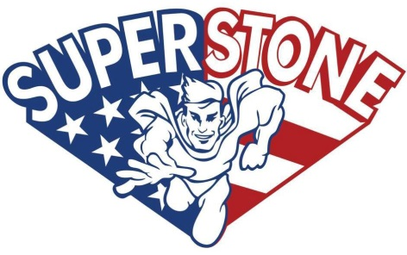
Job Description

Store Manager

Salary Range: $26,000 - $47,000 annually
paid training @ hourly rate $12-$15 per hr.

Working Hours: Monday – Saturday (40+ hrs. a week)

Job Summary:

Super Stone, Inc. are pioneers of the decorative concrete industry serving concrete contractors with quality products, support, and training for over 50 years. Super Stone’s headquarters is located in Miami, FL with additional fully stocked warehouses.

This position is responsible for the day-to-day operations of the store ensuring that it runs smoothly, is clean and meets sales goals with the aid of a sales associate and warehouse staff. The job also requires inventory management, and account reconciliation. The specific duties and responsibilities may change or be increased as assigned and include, but are not limited to:

Principal Duties and Responsibilities:
- Oversee all Sales and Service for your location. Supervise Sales Associates & Warehouse Associates. Ensure quality customer service is being delivered with every transaction.
- Ensure proper scheduling for your location, and communicating in a timely manner when support staff is needed.
- Preparing and tracking purchase orders & invoices. Provide product to customer, use a forklift when needed.
- Maintain inventory, request store transfers, and process product returns.
- Conduct monthly inventory audit and ensure inventory is being rotated for first in/ first out process. Keep shelves stocked and submit customer request inventory requests in a timely manner.
- Manage customer accounts thru exceptional customer service including resolving customer issues at your location and ensuring accountability for yourself and your staff.
- Prepare quotes, cross-sell and periodically review sales reports for pricing accuracy.
- Answer phone calls, collect and distribute mail daily, and greet customers.
- Reconcile cash drawers daily and conduct daily bank cash deposits. Prepare daily sales balance and refund report daily.
- Review daily sales transactions to ensure policy and procedure is being followed.
- Build stronger customer loyalty thru weekly calls to customers for feedback, thank them for their continued business.
- Promote and register a minimum of 2 attendees for each Super Stone Seminar.
- Maintain records of work assignments & accomplishments.
- Adhere to the Opening and closing procedures for store location and securing warehouse.
- Ensure office area is neat and orderly (taking out trash, cleaning bathrooms, cleaning showroom & warehouse floors, dusting, cleaning windows, ensure office is well supplied, equipment is functioning properly, and changing a/c filter monthly).
- Maintain showroom and ensure latest products are displayed along with up-to-date slideshow on TV monitor.
Education & Language:
- Associates degree or High School Diploma or GED with two (2) years equivalent business experience.
- Preference will be given to candidates with industrial supply retail sales experience.
- Able to read, write and converse in English & Spanish preferred.

Experience, Knowledge, Skills and Abilities:
- Minimum of two (2) years of experience in management and sales; product knowledge highly preferred.
- Willing to learn products, specifications and standards, be receptive to feedback and embrace continuous improvement opportunities.
- Experienced in Microsoft Office, Outlook, & QuickBooks.
- Must be customer service oriented and able to interact with the public and vendors in a professional manner.
- Able to present a professional image to customers, with strong oral and written communication skills.
- Must be reliable and able to work independently.
- Prior experience in POS applications, inventory control, tracking and cycle-count experience.
- Ability to work efficiently in a fast-paced environment and be detailed-oriented with good organizational skills.
Physical Demands & Working Conditions:
- Pre-employment drug and background screen; random drug testing applies.
- Must be able to lift 65 lbs.

Rev. 12/17

